Coco’s Preschool Nursery
Where Happy Children Play, Learn And Grow

Blindmans Lane, Waltham Cross, Cheshunt,
Hertfordshire EN8 9DW
Telephone: 01992 262123
Email: cocospreschool@yahoo.co.uk Website:www.cocospre-school.co.uk

Prospectus 2019-2020
Introduction
Coco's Pre-School Nursery or “Coco’s” as it is more commonly referred to is privately owned and was originally established in 1991 and relocated to its current premises in central Cheshunt in 1994.
Coco’s is registered to provide care for a maximum of 50 children. It is registered on the Early Years Register and both the compulsory and voluntary parts of the Childcare Register.
Currently there are 70 children on roll in the early years age group who attend on a part-time or full-time basis. Children attend from the local and wider geographical areas. The setting supports a small number of children who speak English as an additional language.
The nursery is normally open between the hours of 08:00 and 18:00, Monday to Friday, all year round with the exception of Bank Holidays. Safe drop off and pick up is provided at the front of the nursery for parents/carers arriving by car with children at Coco’s.
Coco’s building is divided into: the Lobby” which doubles as the PE room and additional classroom, the “Main Area” used for lunches and snacks and for free play and themed play, a “Library” area or “Raise” used for reading, the “Pink Room” used for the 2yr olds and the “Phonics Room” used for more focussed learning. In addition, there is a large outdoor area to the rear of the nursery divided into physical play and outdoor learning.
We are staffed by a high-quality team of Early Years Practitioners who undertake regular training to ensure up-to-date knowledge and guidance and promote fundamental British Values. Our team acknowledge the formative early years of a child’s life as crucial to their future learning, development and life chances. We believe that every child deserves the best possible start in life, helping them to develop into happy, confident, sociable and independent young people. We achieve this by working closely with parents/carers and families to ensure tailored care and education for each child, guided by their own unique set of experiences, interests and needs. We embrace individuality, equality and diversity. We value every child promoting a culture of respect, confidence and a positive self-esteem.
Early Years Foundation Stage
Our nursery works under the umbrella of the national Early Years Foundation Stage (EYFS), which is guided by four themes:

A Unique Child | Positive  Relationships | Enabling  Environments | Children Learn And Develop In Different Ways And At Different  Rates
Every child is a unique, competent learner from birth who can be resilient, capable, confident and self-assured | Children learn to be strong and independent from a base of loving and secure relationships with parents/carers and/or a key person | The environment plays a key role in supporting and extending children’s development and learning | The EYFS framework covers the education and care of all children in early years provision, including children with special educational needs and disabilities

For more information about the EYFS, please copy & paste this link into your internet browser:

http://www.education.gov.uk/schools/teachingandlearning/curriculum/a0068102/early-years-foundation-stageeyfs
The EYFS curriculum is based around seven areas of learning and development, three Primary Areas and four Specific Areas.
For each child under two, we concentrate on the three Prime Areas:
- Communication and Language
- Personal, Social and Emotional Development
- Physical Development
These areas cover the knowledge and skills required to form the foundations of formal learning. The Prime Areas develop through effective relationships and experiences supporting learning in all other areas. They remain fundamental throughout the EYFS.
For the older children we concentrate on all seven areas. The four Specific Areas of learning and development grow from the Prime Areas and provide important opportunities for extending knowledge:
- Literarily
- Mathematics
- Understanding the world
- Expressive arts and design
At Coco’s we use regular observations of children as they play, learn and socialise to highlight their current interests alongside learning or development aims. These observations input to the children’s individual planning and help us to track their progress as well as identify specific needs.
Reports and Reviews
Once a child has settled into Coco’s, a review of how a child has settled will be written and shared with parents/carers. During this meeting, an Individual Development Plan (IDP) will be created to incorporate both home and nursery perspectives. Children’s progress is monitored on local authority Early Years Outcomes tracking sheets every twice a term and these are available to parents/carers for their contributions. Further reviews are undertaken before transitioning to a new room/setting. More frequent reviews and IDP’s will be undertaken where appropriate.
Children between the ages of two and three will undergo a two-year-old progress report to confirm a child’s readiness to engage with the four Specific Areas. The assessment will enable us to plan for the child’s learning and development.

Learning Opportunities

Our children enjoy a balance of child-initiated and adult-led activities. They are encouraged to make independent choices and develop their critical thinking.

We establish themes for each term, for example “summer” and “growing” which influence the day to day activities:

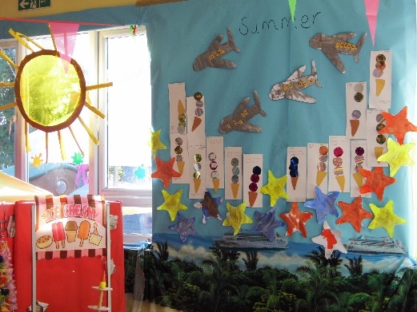 | 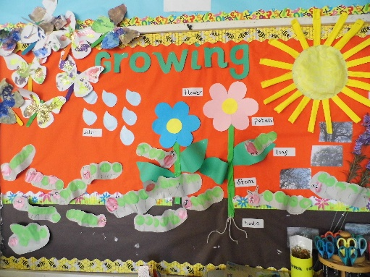

Coco’s has defined areas of learning and activities that are changed throughout the day depending on children’s interests, requests and learning adventures.

Exploring Shapes | Mark Making | Exploring Books
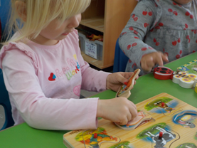 | 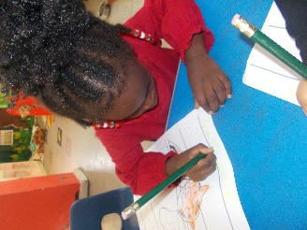 | 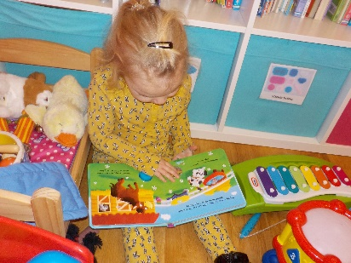
Role Play – Home Corner | Exploring People Who Help Us
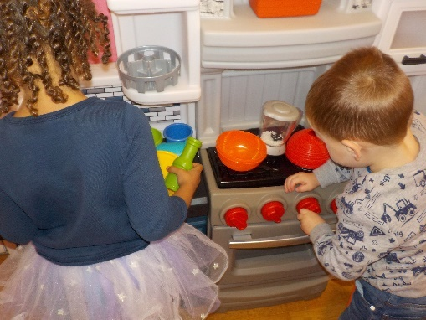 | 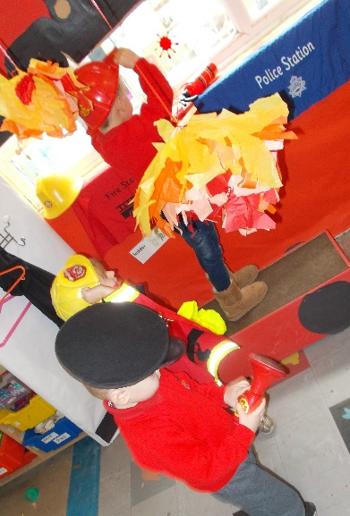 | 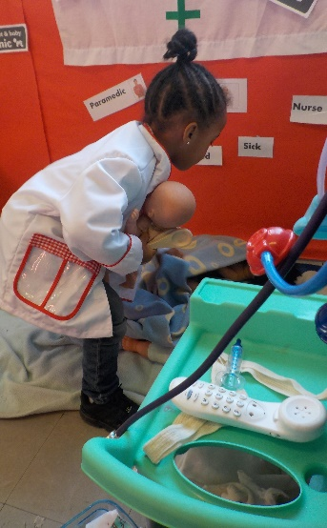

Children are regularly involved in musical activities, arts and crafts and opportunities to investigate, discover and experiment with their ideas.

Through our adult led activities we can introduce children to new ideas, provide opportunities for them to develop their skills and ensure that they experience all areas of learning
Ducks and Ducklings
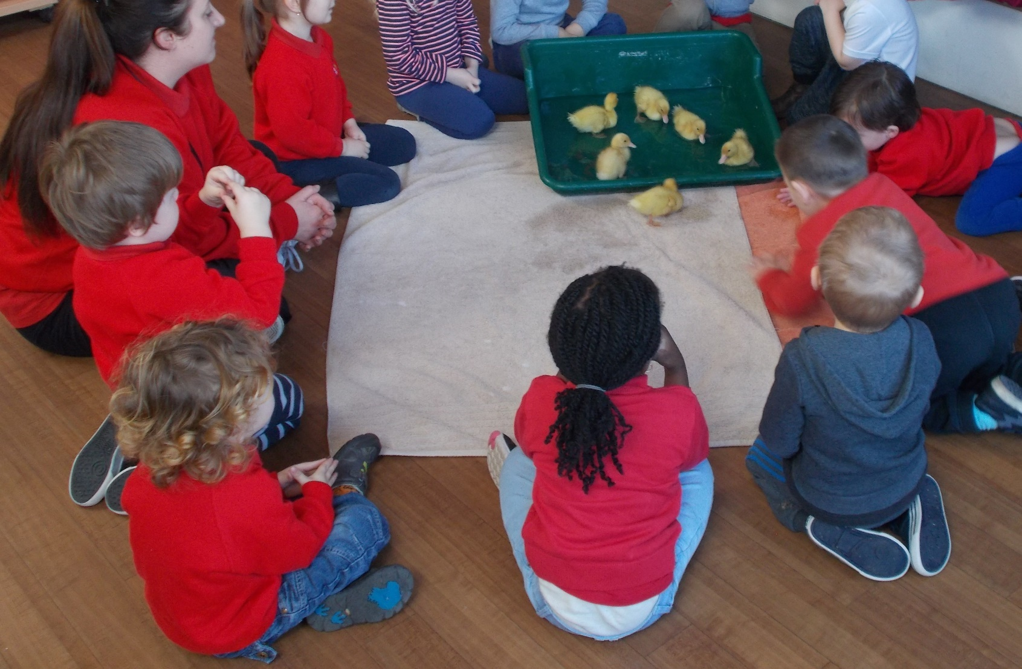

Our children have free play access to a safe, enclosed garden every day. Covered and shaded areas enable use of the garden in all seasons. Children are encouraged to take an interest in their world and care for nature through activities such as discovering mini-beasts or growing flowers, fruit and vegetables. As well as a physical activity with slides, climbing frames and ride-on toys.
The garden also mirrors the inside themes such as reading, maths, construction, plants growth etc offering a wide choice of resources with many learning, social and physical opportunities.
Construction Area |  | Messy Play - Mud Station
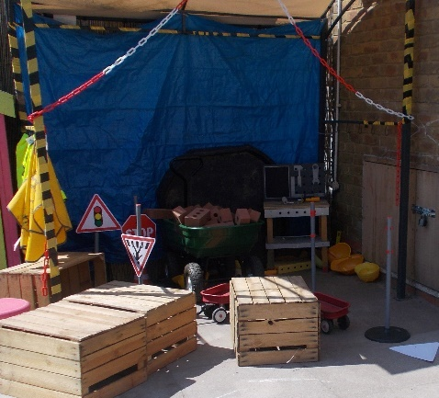 | 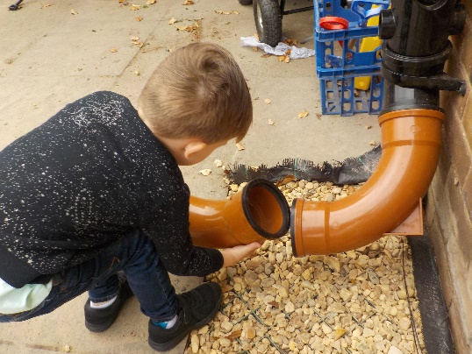 | 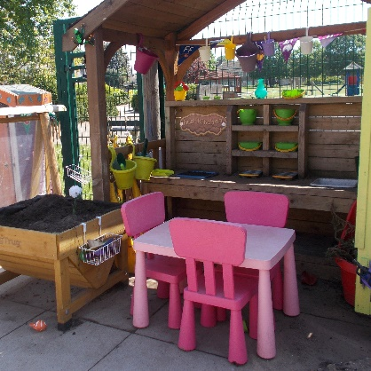
Literacy, Phonics and Mark Making | Maths Area – Maths Shed | Sand Shed
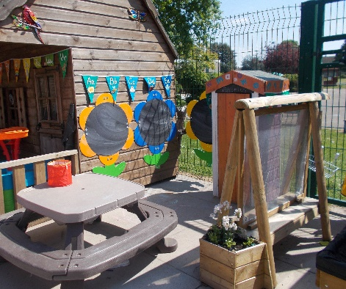 | 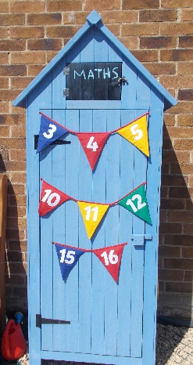 | 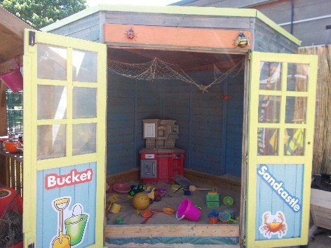
Physical Play – Gross Motor Skills - Slides and Frames |  | Understanding the World – Growing Plants
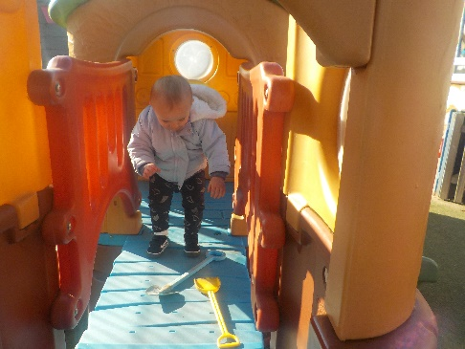 | 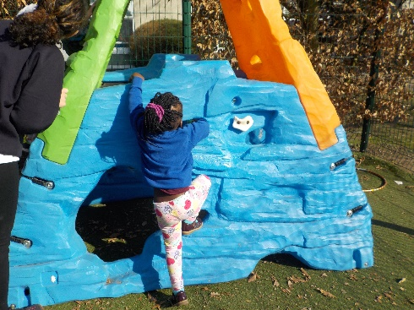 | 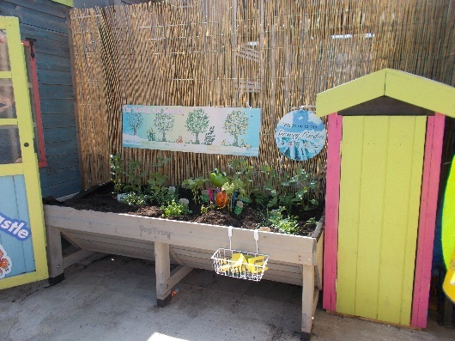

Free play is unstructured, voluntary, and child initiated and has been shown to improve a child’s learning engagement. Free Play is a tool for developing a child as a whole. The skills that it promotes allows children to develop at their own pace.

Our free play is based on a free flow system whereby children can choose to play inside or outside.
Behavioural Development
Through activities, circle times and good adult examples, our children learn to be caring, thoughtful and accepting of others. Children are involved in decision and rulemaking processes, giving them a sense of self-worth, ownership and inclusion. Parents/carers often remark on the development of good manners and consideration in their children once they start at Coco’s.
Community Awareness
We endeavour to provide our children with a variety of experiences to enhance their knowledge of the surrounding community. We have the fire brigade visit once a year, bringing a fire engine with them, we arrange for duck or chick eggs from local farms to be hatched on site and we have companies like Tesco’s to discuss diet and healthy eating.

Tesco Promotes Healthy Eating
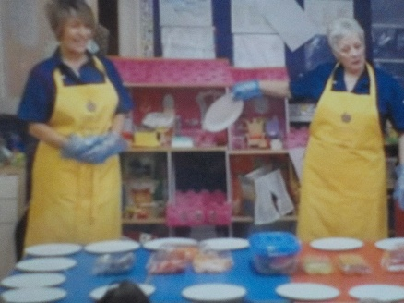 | 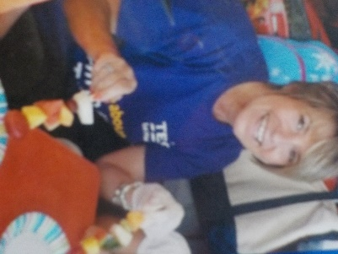 | 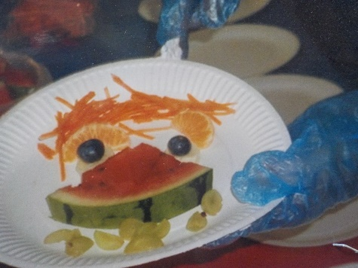

Admissions
Coco’s remains oversubscribed and for this reason all parents/carers are advised to register their child’s name as soon as possible. (see registration form)
Settling In
We understand the importance of children settling in, feeling safe and comfortable in a new environment. We work with parents/carers to devise a settling in process that caters for individual needs. Registration and All About Me forms and talking to parents/carers help staff understand feeding and sleeping routines, children’s interests and comfort strategies.
Each child is assigned a key person who will have the main responsibility of caring, assessing and planning for them as well as building positive working relationships with the child, parents/carers and family. We aim to make Coco’s as homely as possible to promote comfort and security together with a sense of belonging and trust for each and every child and parent/carer.
Parental Partnership
At Coco’s we respect parents/carers as their child’s first and most enduring caregivers and educators. From settling and day-to-day care to assessing and planning, we include and value parental input. It is important for children to witness the good relationships between parents/carers and staff. This is reinforced with regular parental feedback opportunities.
Arrival and Collection
We welcome children into nursery from 08:00 until 18:00. We ask that parents/carers adhere to opening and closing times as we are not registered/insured to care for children outside of these times.
Only named, authorised collectors on a child’s registration form will be permitted to collect that child. In unexpected circumstances, parents/carers can notify us by telephone, giving a password and description of unfamiliar collectors or emailing a photograph.
The nursery reserves the right to charge for late collections – see terms and conditions
Meals and Snacks
Our meals are provided by the adjoining school. They offer a wide variety of nutritious, balanced meals, incorporating any special dietary requirements. In-line with our homely ethos, all staff eat with the children, ensuring a warm and sociable atmosphere. A healthy snack is served during each session along with a drink of milk or water. Drinking water is always available. Our last inspection by the Food Standards Agency gained us top marks (5) in the hygiene scale.

Special Educational Needs (SEN)
Our Local Offer details what we can offer children with SEN. A copy of the Local Offer is available in the nursery reception area and can be emailed on request. We have systems in place to support early identification of children’s needs and work closely with parents/carers (as well as outside agencies where appropriate) to develop effective strategies.

Child Protection and Safeguarding
Coco’s policy is to protect the children at all times. This is in accordance with Government guidelines.
We use a CCTV system to monitor the entrance to Coco’s and a double lock system for the lobby area. Visitors are supervised at all times.
The welfare of all children in our care is paramount. Our rooms, equipment and garden subject to ongoing assessment and new activities or events are risk-assessed prior to engagement.
In line with the statutory EYFS requirements, we practise Safe Recruitment including DBS checks and Annual Declarations.
We have two named Safeguarding Officers and all practitioners are committed to keeping children safe, healthy and happy. Children are taught about good health, self-care and safety through example, stories, discussions and activities.
Policies and Procedures
Our Policies and Procedures are available for parents/carers and visitors to view at any time in the reception area and on our website. Copies can be requested via email.
Complaints
Any concerns should be raised initially with your child’s Key Person or Room Leader. If the matter is not resolved or you would like to speak to a member of our management team, this will be arranged as quickly as possible.
If you are dissatisfied with any aspect of our service, you can contact Ofsted, the regulators of early years’ settings, at:
The National Business Unit
Ofsted
Piccadilly Gate
Store Street
Manchester
M1 2WD
Tel: 0300 123 1231

If you would like further information about Ofsted, you can visit their website at https://www.gov.uk/government/organisations/ofsted

